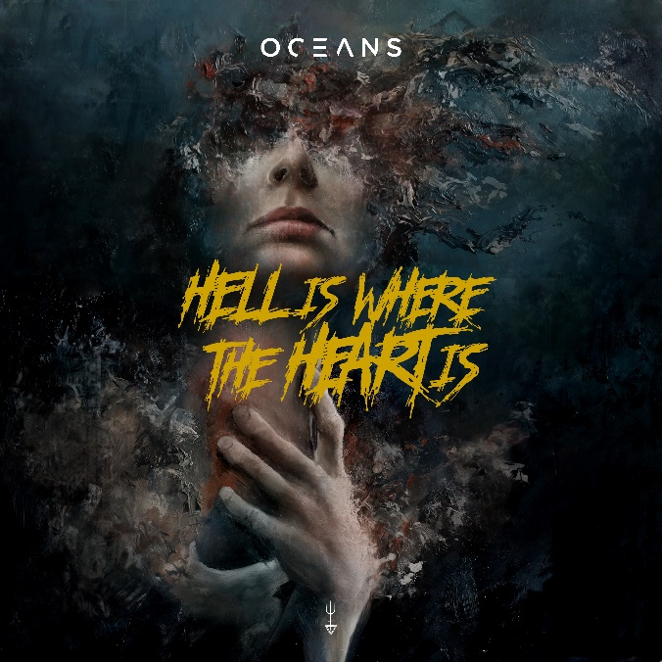

OCEANS

» Hell Is Where The Heart Is «

OUT: November 25th 2022
Line up: | OCEANS online:
Timo Rotten | vocals, guitar  Patrick Zarske | guitar  Thomas Winkelmann | bass  J.F. Grill | drums | www.oceansofficial.com  www.facebook.de/oceansofficialde  www.twitter.com/ocnsofficial  www.youtube.de/oceansofficial  www.nuclearblast.de/oceans
The withered and lonely heart longs for warmth and comfort. The harder the concrete, the mightier the flower that breaks through it. The more the heart has been broken, the stronger its love flourishes. Alas, the stronger the love, the harder the pain that unavoidably comes with it. Only a dead heart feels no pain, but is also devoid of love. The older the heart, the more scarred it becomes. The scars bear witness to the bond of life and love. They show that the heart has not given up beating.
The more withered the lonely and scarred heart becomes, the more it craves to withdraw itself to a far away place. Once there, it hopes to find repose and solace. But this makes the heart a prisoner in a golden cage, its wings clipped. From such a place, the heart cannot truly depart to new havens. It is trapped. So it begins to dream. It dreams of far off worlds and, as it spends its time yearning for change, the chains rust. Life fades from the little heart, until its only wish becomes to be surrounded by silence alone.
All the pain of life - the sorrow over bygone times, missed chances and lost love - finally gives way to the epiphany that all of it only happened because the heart has lived. It has lived, loved and dreamed. It has breathed the spirit of freedom and survived a thousand deep cuts. The scar tissue suddenly becomes a magnificent garment, a token of strength. The little heart will proudly wear it for as long as it keeps beating, understanding that hell awaits around every corner. Because hell belongs to the heart, as the heart belongs to hell. One cannot exist without the other. They are the light and the darkness. The chaos and the nothing.
Hell is where the heart is.
Where the heart is, there is life.
And life is stronger than any pain the world could ever hold.

